There are three logical operators

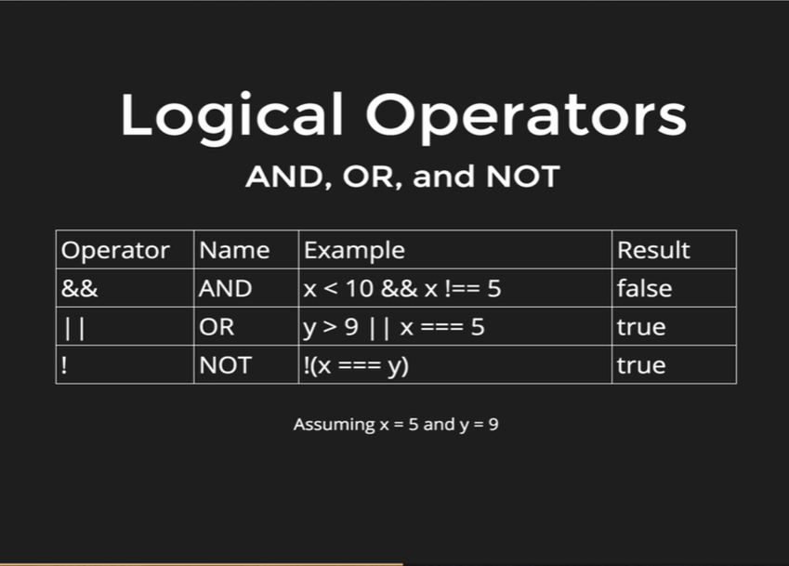

Those three operators are called AND (&&), OR (||) and NOT (!).

We are going to start with AND. AND takes two sides, the left side and the right side and AND goes in the middle. So, we will evaluate both sides where x is less than 10 that is true, and x is not equal to 5 and that is false. So, we end up with True and False, and the way AND works it requires both sides to be true, left and right and that is not true in this case, only the left side is true and that is why the entire statement is false.

The way OR works is slightly different, it still evaluates both sides, but it only requires one of the sides to be true. The left or right to be true for the whole statement to be true. Y is greater than 9 which is not true, but x is triple equals to 5 which is true, thus the entire statement is true.

Lastly, we have NOT, and the way NOT works is a little bit different. It does not take left or right side; it just negates or flips the value of whatever we apply it to. So, if something was true and we put a NOT in front of it, it then becomes false, if something was false and we put a NOT in front of it, it then becomes true. So, in this case the expression x is triple equal to y which is false, as 5 is not equal to 9, so the statement inside the parentheses is false but there is a negation in front of it which negates the whole thing and turns the statement to be true.

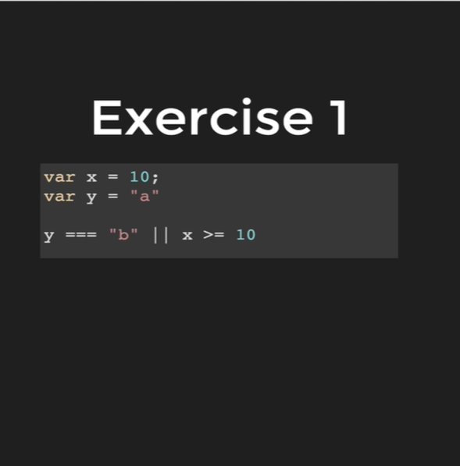

True

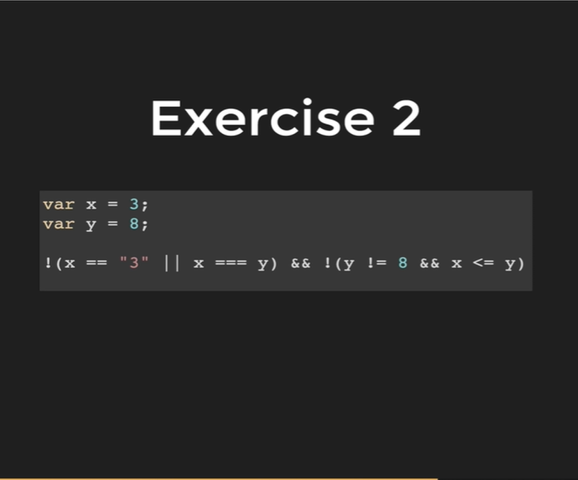

False